**Task: Documenting code in flowchart format**

Description: Read and understand the code on the repositories and create a flowchart showing the methods and conditional statements that are written on the code. Use flow2code online application for easy flowchart documentation: <https://code2flow.com/>

Read the code on the zip file attached on the email.

Example:

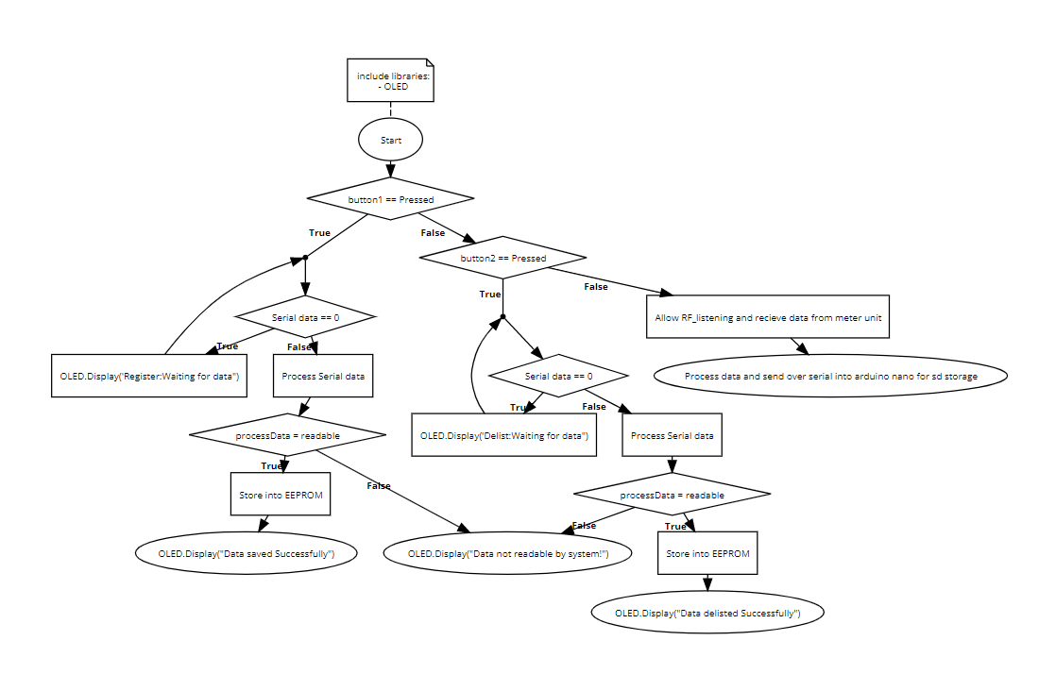

Assignees:

Main unit:

* + Mark Neil
  + Benjie
  + Michelle Ann

Meter Unit:

* + Lyndon
  + Renante